ASHA Certification Verification DIRECTIONS

Verify that your Supervisor’s Certificate of Clinical Competence in Speech-Language Pathology (CCC-SLP) is current with ASHA. This must be done on the first day at your site. If your supervisor’s CCC’s are NOT current, contact the Clinic Director ASAP to find a different supervisor.

Go to: www.asha.org/certification and enter the ASHA Account Number or search by name and state.
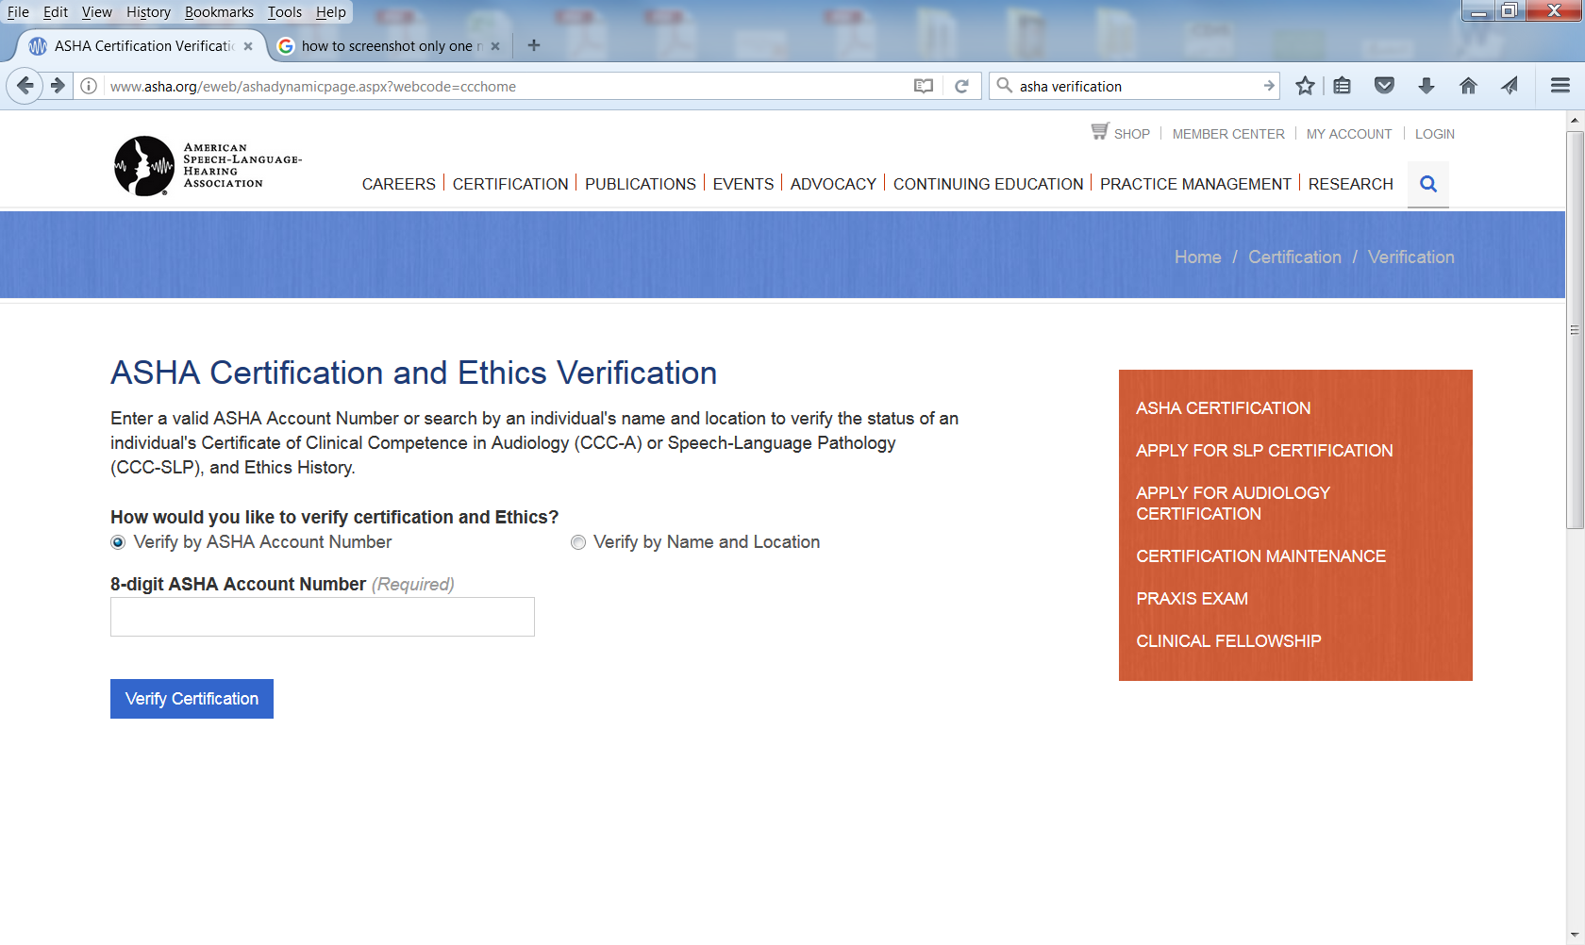

Click on the SLP name to get to the ASHA Certification Verification page.
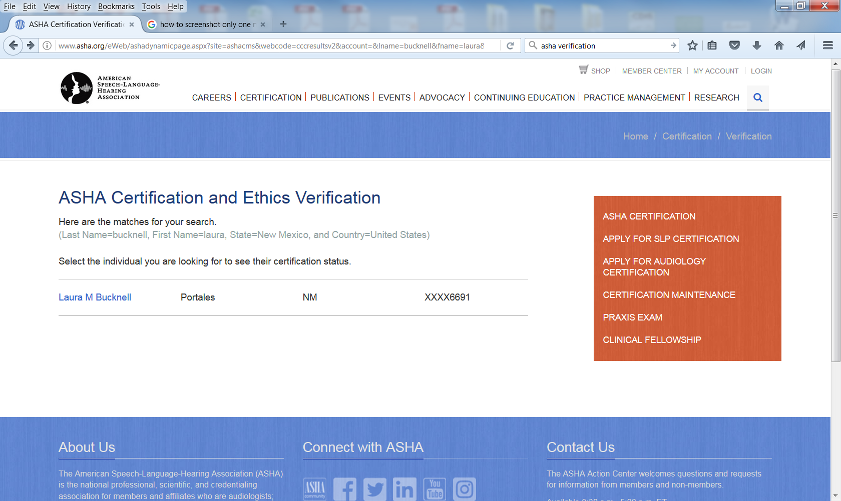

Scroll down to the Generate Verification Letter and enter your name and address.
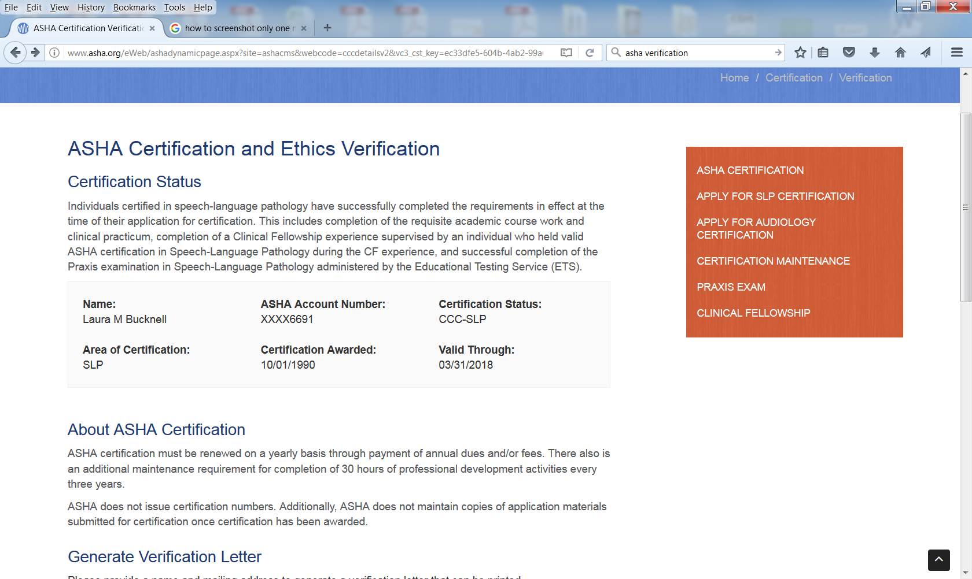
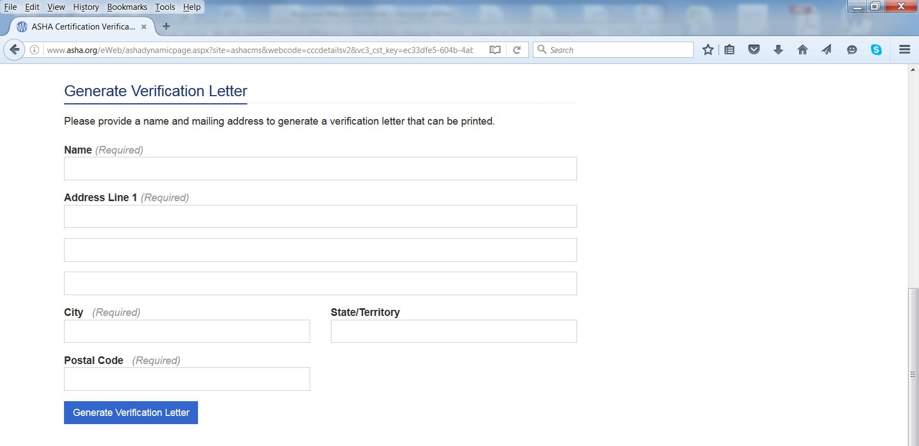
Hit blue tab Generate Verification Letter.

Print the verification letter and mail in with your original practicum forms to the clinic director.

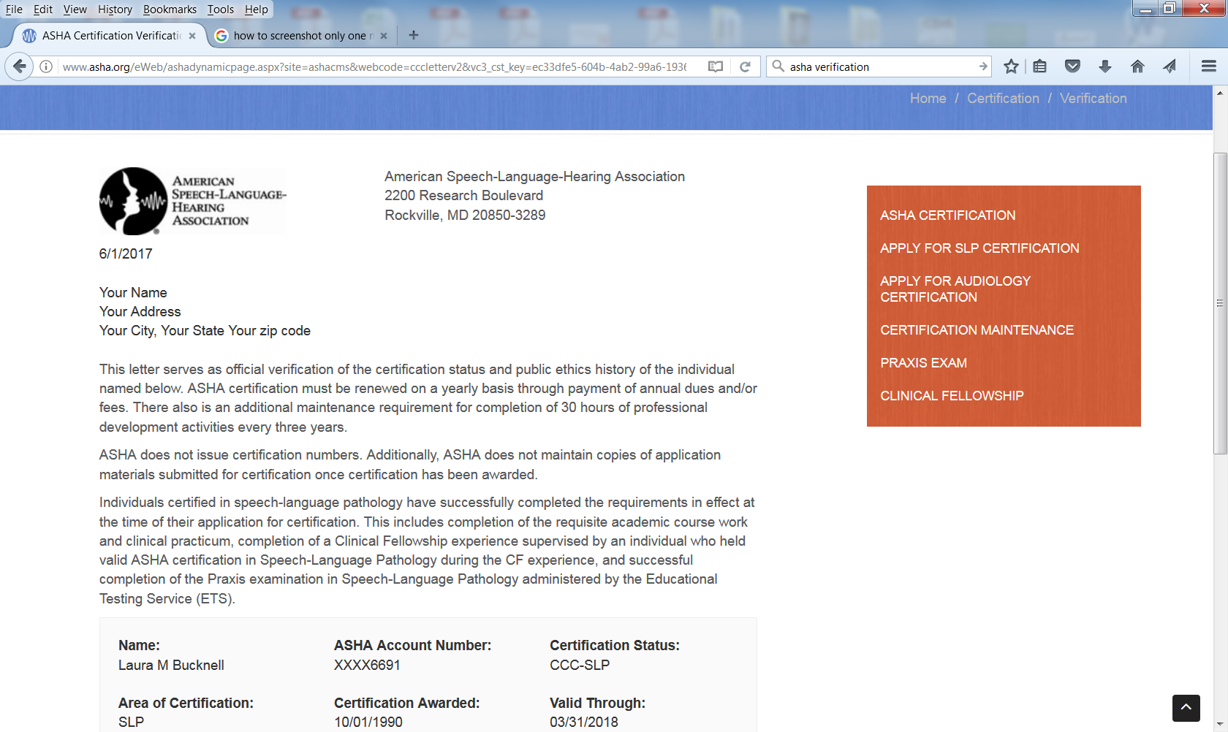

***** This needs to be submitted with your Practicum Form Packet *****

